Running head:  
Scientific Notes

Membership status:  
Member (Austin N. Fife, ID)

Billing contact:  
Austin N. Fife  
The University of Florida - North Florida Research and Education Center  
155 Research Road  
Quincy, 32351, USA  
Phone: +01 (850) 875-7100  
E-mail: afife@ufl.edu  
Include any information (reference number, tax ID, etc.) that you need included on the invoice

**First report of *Phyllocoptes fructiphilus* in Florida**

Austin **Fife**1*, Sam **Bolton**2, Mathews **Paret**3, and Xavier **Martini**4

1 University of Florida, Department of Entomology and Nematology, Gainesville, Florida, 32611, USA, E-mail: afife@ufl.edu

2 The Florida Department of Agriculture and Consumer Services, Division of Plant Industry, Gainesville, Florida, 32614, USA, E-mail: Samuel.Bolton@FDACS.gov

3 University of Florida, Department of Entomology and Nematology, Gainesville, Florida, 32611, USA, E-mail: paret@ufl.edu

4 University of Florida, Department of Entomology and Nematology, Gainesville, Florida, 32611, USA, E-mail: xmartini@ufl.edu

*Corresponding author; E-mail: afife@ufl.edu

*Phyllocoptes fructiphilus* is a microscopic plant-feeding arachnid known as an eriophyid mite. *P. fructiphilus* is very host specific, only feeding on plants in the genus *Rosa*, and rarely causes observable damage to their host. Unfortunately, *P. fructiphilus* has become infamous due to a virus known as Rose Rosette Virus (RRV), which the mite transmits while feeding. RRV infection creates the following symptoms: witches’ brooms/rosetting, deformed flowers, increased prickle density, elongated shoots, reddened leaves and stems, and increased die-back which ultimately kills the rose host. This disease is known as Rose Rosette Disease (RRD) and is the most serious disease of roses, creating millions of dollars of losses for growers. Rose Rosette Disease and the mite have invaded the southeastern united states as they followed the range expansion of the non-native *Rosa multiflora* (Thunb) towards the coast (Amrine Jr 2002, Otero-Colina et al. 2018).

RRD has also been detected in Florida as well. In 2014, 15 roses were found with symptoms of RRD (Babu et al. 2014). The virus was confirmed using molecular methods (Babu et al. 2016, 2017) and the plants were destroyed. *P. fructiphilus* were not detected on the roses at that time.

In 2018 the entomology lab at the North Florida Research and Education Center began a series of surveys along the borders of northern Florida and southern Georgia. The purpose of this survey was to find predatory phytoseiid mites on roses which may be natural predators of *P. fructiphilus*. This survey was also meant to discover any RRD in Florida so it could be eradicated before it could spread further.

On February 14, 2019, we found a total of 42 eriophyid mites of unknown identity from six samples obtained while surveying roses in Leon County, Florida. (see *Figure 1*) The mites were sent to the Florida Department of Agriculture and Consumer Services - Department of Plant Industry (FDACS-DPI) June 10th and confirmed as *P. fructiphilus* by the acarologist Dr. Sam Bolton the 2nd of July. The roses did not show signs or symptoms of RDD. These roses were tested for RRV with qPCR and RPA by Dr. Fanny Iriarte at the NFREC Plant Disease Diagnostic Clinic (PDC), following the methods of Babu et al. (2016) and Babu et al. (2017). The tests came back negative for both tests, with no virus detected.

The FDACS-DPI conducted a follow-up survey on the 8th of July of the three roses where the mites were initially detected. On July 10th, Dr. Bolton again confirmed the presence of *P. fructiphilus* in all samples tested. RRD symptoms were absent, and tests by Dr. Kishore Dey from the FDACS-DPI were also negative for RRV.

In response to this discovery, on July 16th the NFREC conducted a small survey of 33 roses near the initial site of discovery, including the rose sites where *P. fructiphilus* were originally detected. (see *Figure 1*), Each sample contained more than 50 eriophyid mites, with some samples containining over 300 mites (see *Figure 1, Figure 2*). These mites were again confirmed as *P. fructiphilus* by Dr. Bolton during the month of September, 2019. Additional roses were tested for RRV by Dr. Fanny Iriarte at the PDC and again no virus was detected.

Figure 1: Comparison of sites where *Phyllocoptes fructiphilus* were detected in Leon County, Florida. Pink points indicate sites sampled which had *P. fructiphilus*. Gray areas indicate previously surveyed areas where no *P. fructiphilus* were found.

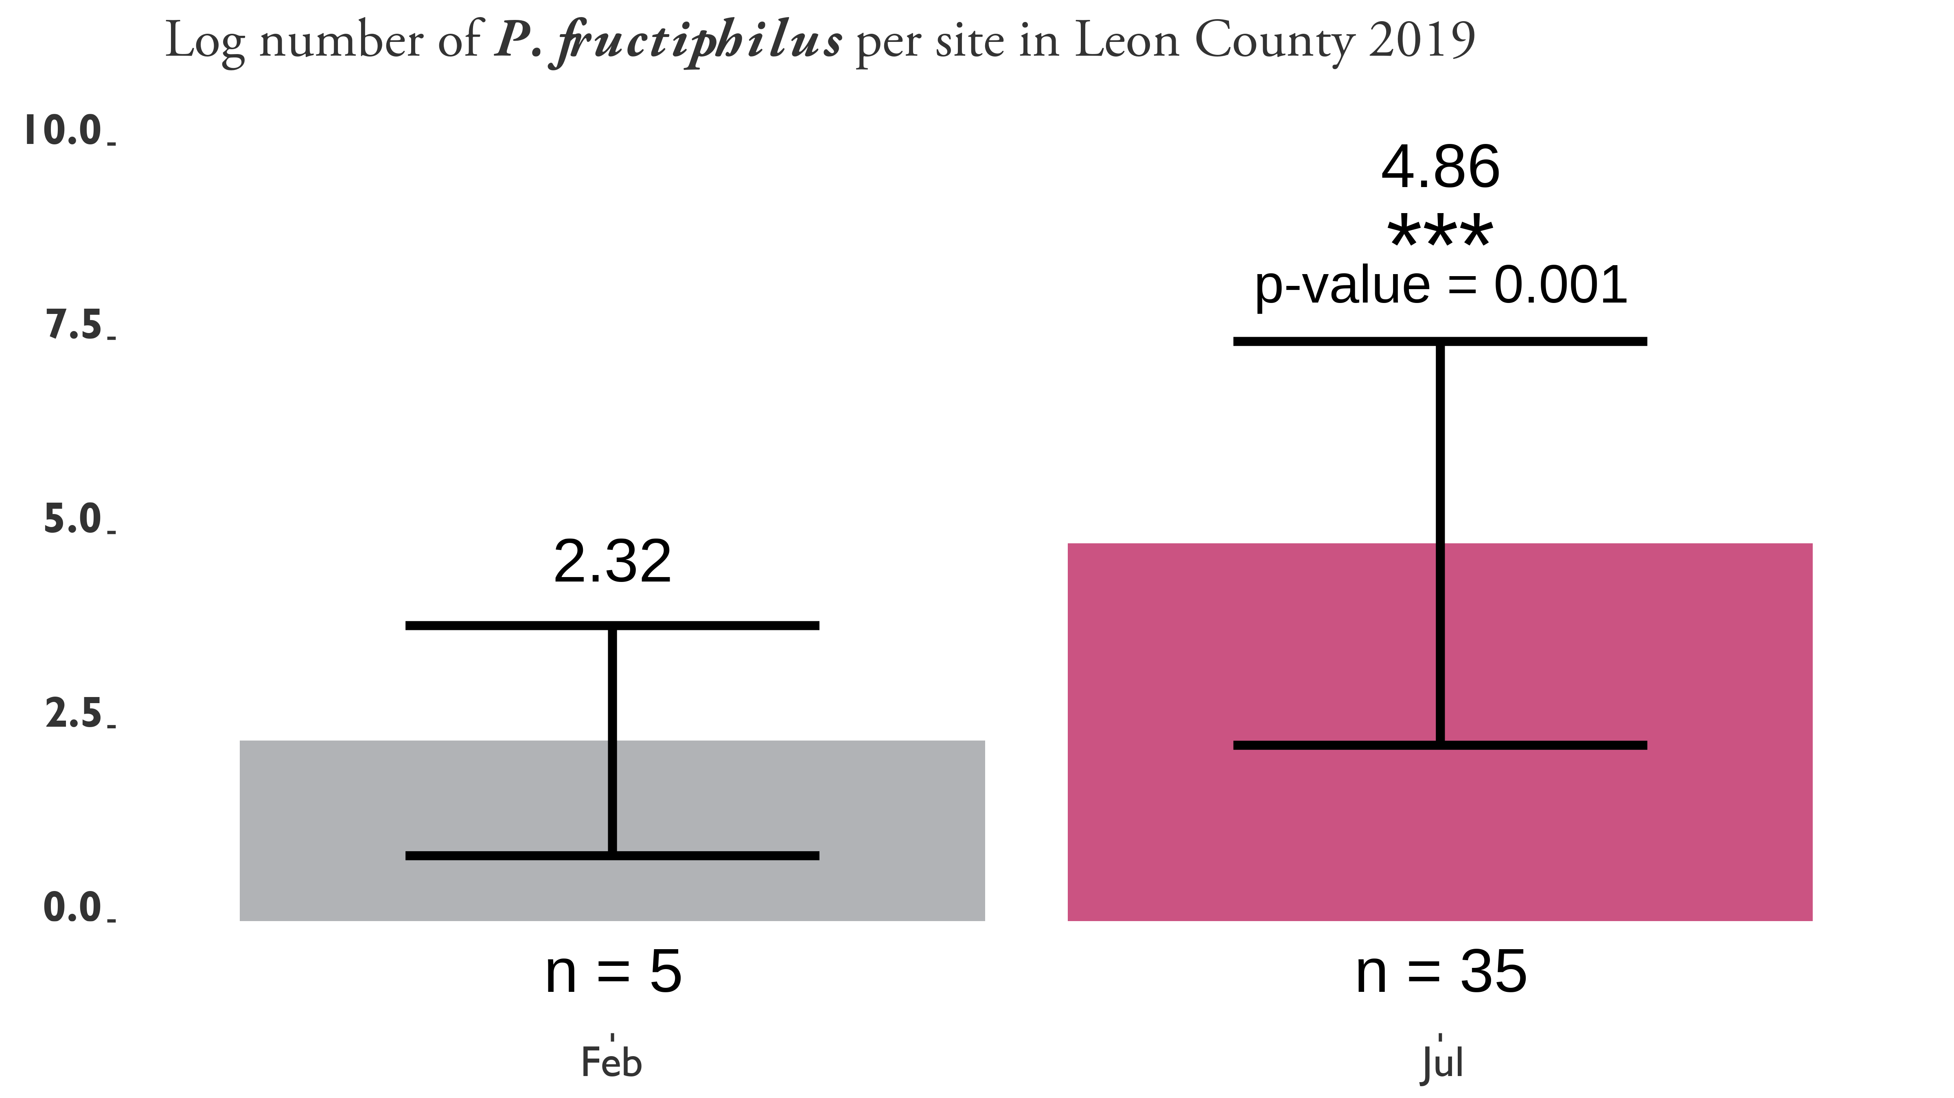

Figure 2: Log number of *Phyllocoptes fructiphilus* per rose sample. Samples were taken from sites in Leon County, Florida during two different months, February 14 and July 16th, 2019. Asterisks represent significant differences as calculated by pairwise t-tests of the 5 sites tested for *P. fructiphilus* during both months. a = 0.05, p-value = 0.001.

*P. fructiphilus* had never been previously detected in Florida. RRV is currently not established in Florida. None of the mite-infested roses had symptoms of RRD. Neither the PDS nor the FDACS-DPI detected the virus in tissue from the infested roses. However, the presence of *P. fructiphilus*, along with past detections of RRV in Florida warrants increased monitoring for the mite and virus in Florida. History has shown that where the mite has spread the virus follows. There is also a need to develop methods to manage *P. fructiphilus* and RRV, or the US rose industry stands to lose millions on mite control.

We are thankful to the Florida Department of Agriculture and Consumer Services for their assistance in mite identification

Summary

The invasive mite *Phyllocoptes fructiphilus* (Acari: Trombidiformes, Eriophyidae) feeds on plants in the genus *Rosa* and is known as the primary vector of Rose Rosette Disease (Bunyavirales: Emaraviridae). *Phyllocoptes fructiphilus* is reported for the first time in Florida, USA. No roses showed signs or symptoms of viral infection, and no virus was detected using molecular methods. *Phyllocoptes fructiphilus* represents a potential threat to Florida roses if Rose Rosette Disease becomes introduced.

Key Words: Rose Rosette Disease; Rose Rosette Virus; Emaravirus

**References Cited**

**Amrine Jr, J. W.** **2002**. *Rosa multiflora*. Biological control of invasive plants in the Eastern United States. 265–292.

**Babu, B., H. Dankers, E. Newberry, C. Baker, T. Schubert, G. Knox, and M. Paret**. **2014**. First report of rose rosette virus associated with rose rosette disease infecting knockout roses in Florida. Plant Disease. 98: 1449–1449.

**Babu, B., A. Jeyaprakash, D. Jones, T. S. Schubert, C. Baker, B. K. Washburn, S. H. Miller, K. Poduch, G. W. Knox, F. M. Ochoa-Corona, and M. L. Paret**. **2016**. Development of a rapid, sensitive TaqMan real-time RT-PCR assay for the detection of rose rosette virus using multiple gene targets. Journal of Virological Methods. 235: 41–50.

**Babu, B., B. K. Washburn, T. S. Ertek, S. H. Miller, C. B. Riddle, G. W. Knox, F. M. Ochoa-Corona, J. Olson, Y. Z. Katırcıoğlu, and M. L. Paret**. **2017**. A field based detection method for rose rosette virus using isothermal probe-based reverse transcription-recombinase polymerase amplification assay. Journal of Virological Methods. 247: 81–90.

**Otero-Colina, G., R. Ochoa, J. W. Amrine Jr, J. Hammond, R. Jordan, and G. R. Bauchan**. **2018**. Eriophyoid mites found on healthy and rose rosette diseased roses in the United States. Journal of Environmental Horticulture. 36: 146–153.